7COM1079 Coursework 2: generative adversarial networks for retinal, network-traffic and sketch data
Student Name:
Student Id:
Github URL: https://github.com/nithinreddy2003/GAN_Assignments
1. Overview and aims
This report describes the GANs built in the accompanying notebook, the reasons for each design choice, and what the results show. Part 1 builds two GANs from scratch on synthetic 2D data and then studies an architecture change. Part 2 applies GANs to three domains that stress a model in different ways: retinal OCT scans, network-traffic records and hand-drawn sketches. The framework suits each task, with PyTorch used for the from-scratch, medical and sketch work and TensorFlow/Keras for the tabular traffic model. All runs use fixed seeds (TORCH_SEED = 3030 for PyTorch, SEED = 4040 for Keras) so the numbers and figures reproduce.
Every model follows the adversarial idea of Goodfellow et al. (2014): a generator turns noise into samples while a discriminator scores how real they look, and the two train together under the non-saturating binary cross-entropy loss. Convolutional DCGANs (Radford et al., 2016) handle the image and sketch data, and a fully-connected network handles the tabular traffic. The report interprets the results instead of restating the code.
2. Part 1: GANs built from scratch on 2D data
Both 2D models are small MLPs trained with the non-saturating loss and Adam at a learning rate of 2e-4. A 24-dimensional latent vector feeds a generator of hidden width 192, and one shared, configurable pair of networks serves all three tasks, so the Task 3 comparison changes only the generator. Training adds a little instance noise to the inputs that decays from 0.1 to 0 over the run, which steadies the early updates.
2.1 Task 1: reproducing the sine-wave GAN
The first target is points on y = sin(x), trained for 6,000 steps. In Figure 1 the generated cloud lies close to the curve across the domain, and the losses settle near the theoretical balance, ending at D = 1.3855 and G = 0.6923 (about 2ln2 = 1.386 for the discriminator and ln2 = 0.693 for the generator). Neither loss runs away, so the shared training loop works before it meets a harder target.
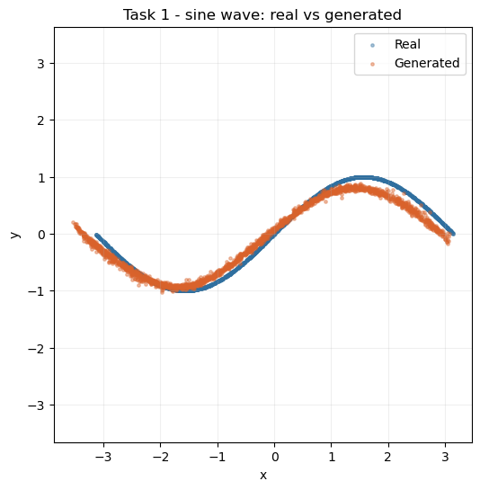
Figure 1. Real (blue) versus generated (orange) samples for the sine-wave GAN after 6,000 steps.
2.2 Task 2: a 2D spiral
The new distribution is a two-arm 2D spiral, a thin curved manifold that a weak GAN tends to collapse into a blob. After 8,000 steps the generator traces both arms and the central curl, as Figure 2 shows, with losses holding stable (final D = 1.4463, G = 0.6583). Covering the spiral without collapse confirms the model has learned a connected, curved manifold across its full extent.
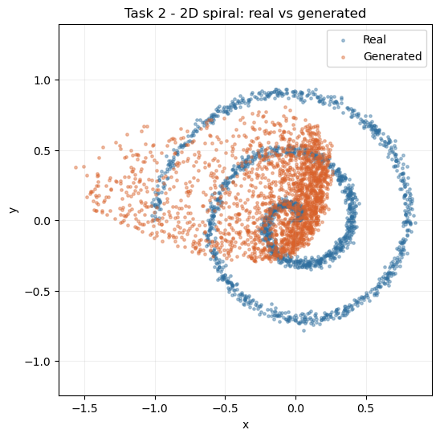
Figure 2. Real versus generated samples for the 2D spiral after 8,000 steps.
2.3 Task 3: architecture modification and comparison
Task 3 keeps the spiral target and budget fixed and changes only the generator, moving from the depth-3 GELU baseline to a deeper depth-5 generator with LeakyReLU(0.3). Figure 3 places the two side by side against the real spiral. The deeper LeakyReLU generator sits a little tighter on the arms with fewer stray points, and its losses stay stable (final D = 1.4649, G = 0.6906), so the added depth does not destabilise training. The gain is modest because a 2D spiral is simple enough for the baseline to capture most of its shape already.
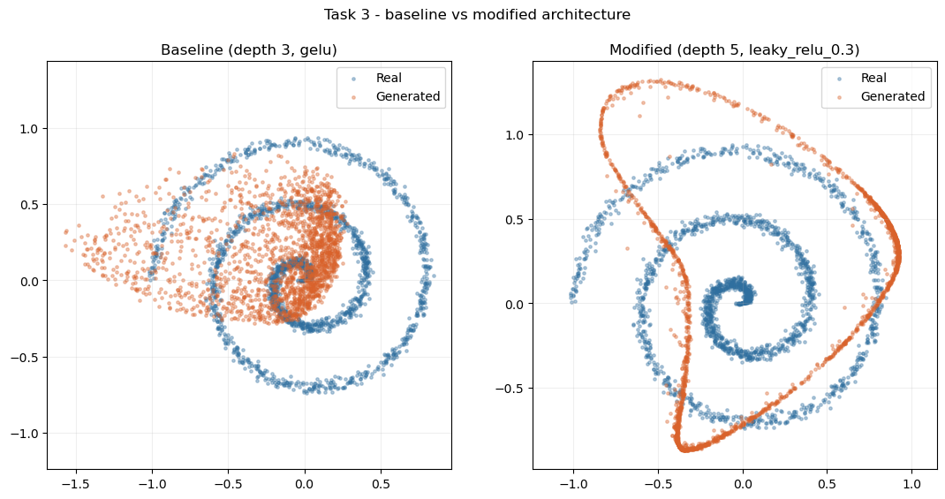
Figure 3. Baseline (depth 3, GELU) and modified (depth 5, LeakyReLU) generators against the real spiral.
3. Part 2: applying GANs to three real-world domains
3.1 Part 2.1: retinal OCT scans with OCTMNIST
OCTMNIST (Yang et al., 2023) holds 97,477 training scans of 28x28 pixels in four diagnostic classes, resized to 32x32 in [-1, 1] to match the generator's tanh output. Figure 4 shows an uneven class distribution, which matters for the conditional extension because the minority classes then train on less data. A DCGAN (Radford et al., 2016) suits the local structure of a scan, a curved retinal band on a dark background. The generator builds the image with nearest-neighbour upsampling followed by 3x3 convolutions, a resize-convolution design that avoids the checkerboard artefacts of transposed convolutions (Odena, Dumoulin and Olah, 2016); the discriminator mirrors it with strided convolutions, BatchNorm and 0.25 dropout. A 100-dimensional latent vector and 64 base feature maps train for 45 epochs with one-sided label smoothing.
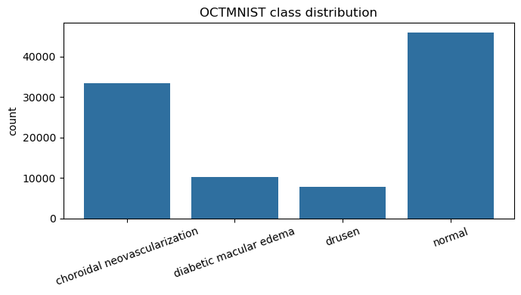
Figure 4. Class distribution of the OCTMNIST training split.
Figure 5 tracks the 45-epoch run: the discriminator mostly stays between about 0.4 and 1.2, with occasional spikes, while the generator moves in a 1 to 5 band, oscillating without divergence. In Figure 6 the generated scans reproduce the bright retinal band with real variation in position and curvature, so the model is not memorising one image; the fakes are softer and lose fine sub-layer texture. The score is FID = 31.94 (Heusel et al., 2017), a good mid-range result for a 45-epoch model, though it should be read as indicative because FID passes single-channel scans through an ImageNet-trained InceptionV3 (Szegedy et al., 2016) that was never calibrated for medical images.
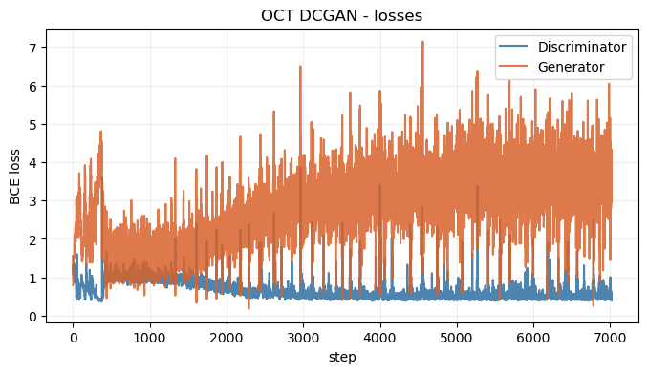
Figure 5. Generator and discriminator loss curves for the OCTMNIST DCGAN.
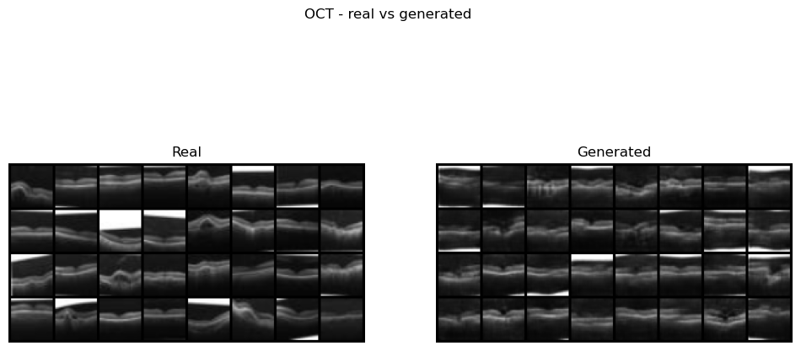
Figure 6. Real (left) versus generated (right) OCT scans from the trained generator.
For class control I added a conditional GAN (Mirza and Osindero, 2014). The critic uses spectral normalisation (Miyato et al., 2018) for a smoother decision boundary and is trained on three cases: a real scan with its correct label, a generated scan with its label, and a real scan carrying a deliberately wrong label scored as fake. That wrong-label case forces the critic to check that an image matches its class as well as looking real. Figure 7 shows one class per row with visibly different scans, and the losses stay stable across 45 epochs (discriminator near 1.24, generator near 1.19).
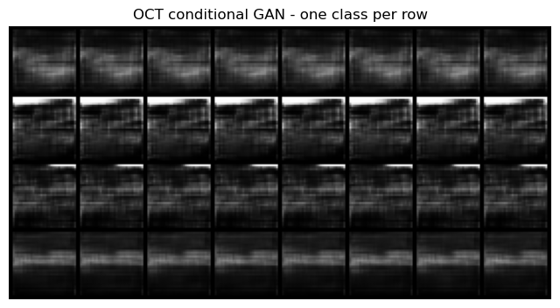
Figure 7. Class-conditional samples, one diagnostic class per row.
On the 'ducks' question: the discriminator only judges whether a scan looks real, never whether it is anatomically valid, so the generator can invent convincing structure that no real patient produced. Synthetic OCT scans are therefore useful for augmentation or teaching but must not be treated as diagnostic ground truth, and any model trained on mixed data should be re-checked on real-only data.
3.2 Part 2.2: network-traffic synthesis with CICIDS 2017
CICIDS 2017 (Sharafaldin et al., 2018) was combined from its eight daily files into 2,830,743 flows across 80 columns (78 numeric features), with 4,376 infinite and 1,358 missing values removed. Figure 8 shows the heavy class imbalance on a log scale, with BENIGN dominating at 2,273,097 flows against much rarer attacks. Because each flow is a feature vector with no spatial layout, a fully-connected GAN replaces the DCGAN, built here in TensorFlow/Keras as a keras.Model subclass with its own train_step. The generator maps noise through Dense layers of 256 then 512 units (BatchNorm and ReLU) to a linear output, since the standardised features are unbounded; the discriminator narrows 512 to 256 units with LeakyReLU and 0.3 dropout. Following the brief, training uses the Wednesday file (691,406 rows, 440,031 BENIGN plus DoS variants), sampled to 20,000 rows.
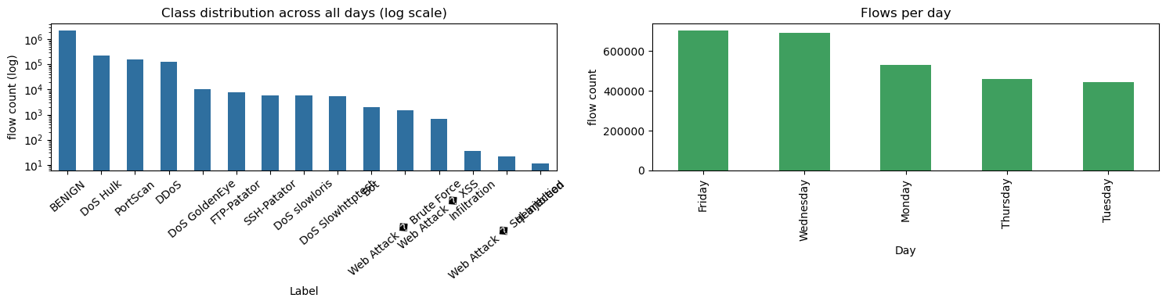
Figure 8. Class distribution across all days (log scale) and flows per day.
Figure 9 shows stable training, with the discriminator and generator losses settling near 1.07 and 1.41. Because 78 numbers cannot be read by eye, the synthetic and real vectors are compared by projection. Figures 10 and 11 show PCA and t-SNE (van der Maaten and Hinton, 2008): the synthetic points sit on the main body of real traffic but in a tighter cloud that misses the outer spread. The per-feature alignment gaps put numbers on this, with a mean absolute error of 0.4792 on the feature means and 0.5522 on the standard deviations, so the generator finds the right region but understates the variance.
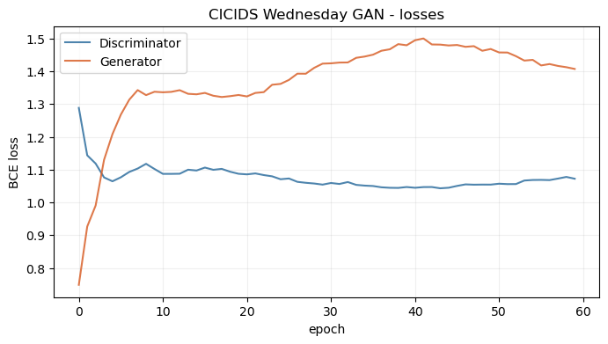
Figure 9. Discriminator and generator loss curves for the Wednesday feature-vector GAN.
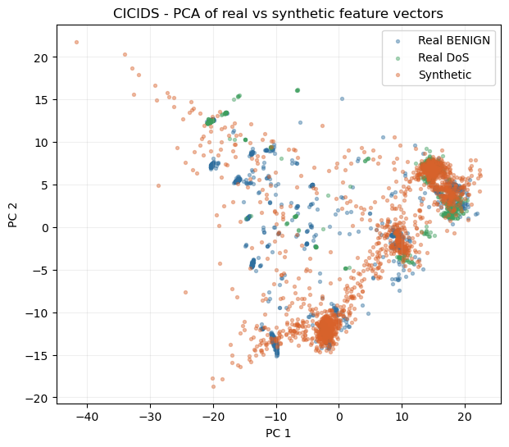
Figure 10. PCA projection of real versus synthetic feature vectors.
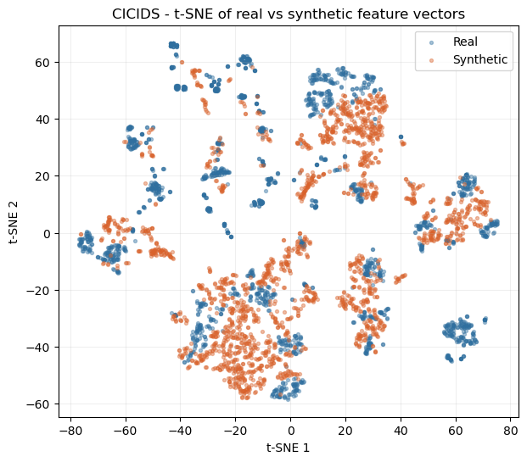
Figure 11. t-SNE projection of real versus synthetic feature vectors.
Retraining on 30,000 rows drawn from all eight days widened the gaps to 0.5675 on the means and 0.6285 on the standard deviations. Asking one unconditional generator to cover many attack families at once made alignment harder, so the extra diversity cost more than the added data returned; a class-conditional model, or one model per family, is the clear next step. A wording note follows the brief: the Wednesday file holds single-source DoS attacks, and genuine DDoS appears only in the Friday file included in the all-days run. The duck point is sharper here, because a synthetic flow can look statistically plausible while being physically impossible, so the per-feature gaps matter more than any visual check.
3.3 Part 2.3: sketch generation with QuickDraw
The final task trains a PyTorch DCGAN on the QuickDraw 'birthday cake' set (Ha and Eck, 2018), 144,982 bitmaps of 28x28 pixels, using a 100-dimensional latent vector and the DCGAN weight initialisation of Radford et al. (2016). Figure 12 compares real and generated cakes: the shapes are clearly readable, with a rounded or rectangular body and candle-like marks on top, and the flaws are the usual line-art ones such as broken strokes and speckle.
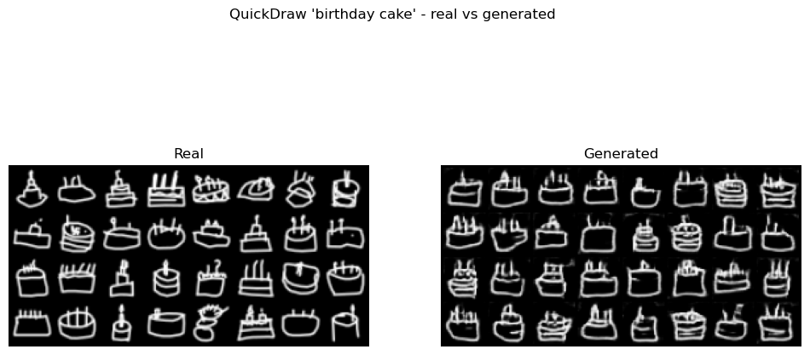
Figure 12. Real (left) versus generated (right) birthday-cake sketches.
Running the same pipeline on two more categories gives the comparison in Figure 13. By FID the order is house (28.76), then cake (41.01), then cat (67.36), while the ink-density proxy is nearly flat across the three (0.1721, 0.1967, 0.1986). Since ink density barely varies, it does not explain the difficulty. House shapes are close to a rigid template and score best, whereas cats vary far more in pose and detail and score worst, so structural variety drives difficulty more than the amount of ink.
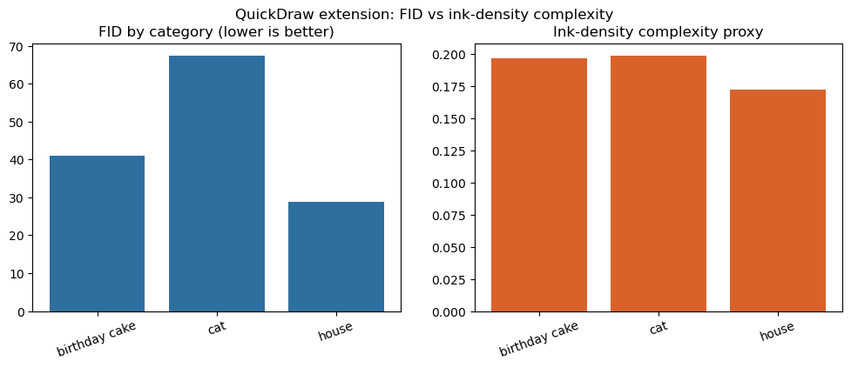
Figure 13. FID by category alongside the ink-density complexity proxy.
4. Reflections and future directions
The same adversarial recipe adapted to very different data by changing the input representation and the network family: MLPs for 2D points, a resize-convolution DCGAN for OCT scans, a fully-connected GAN for tabular traffic, and a standard DCGAN for sketches. The from-scratch models reached near-theoretical equilibria, the OCT DCGAN produced varied scans at FID 31.94, and the sketch DCGAN produced readable cakes at FID 41.01. The tabular model matched the region of real traffic but understated its spread (gaps 0.4792 / 0.5522 on Wednesday, widening to 0.5675 / 0.6285 across all days), and the conditional OCT model generated a chosen class on demand.
The recurring limitation is coverage: central tendency is reproduced more faithfully than variance, and rare classes are served worst. Future work follows from this. Conditioning the traffic generator on attack family, as done for OCT, would help it reach rare attacks instead of leaning on BENIGN. A Wasserstein objective with a gradient penalty (Gulrajani et al., 2017) would likely tighten the tabular spread and the standard-deviation gap. A domain-appropriate feature extractor would give a fairer image score than ImageNet InceptionV3. Above all, the duck-test analysis means synthetic medical or security data must be validated on real-only data before any downstream use.
References
Goodfellow, I., Pouget-Abadie, J., Mirza, M., Xu, B., Warde-Farley, D., Ozair, S., Courville, A. and Bengio, Y. (2014) 'Generative adversarial nets', Advances in Neural Information Processing Systems, 27, pp. 2672-2680.
Gulrajani, I., Ahmed, F., Arjovsky, M., Dumoulin, V. and Courville, A. (2017) 'Improved training of Wasserstein GANs', Advances in Neural Information Processing Systems, 30, pp. 5767-5777.
Ha, D. and Eck, D. (2018) 'A neural representation of sketch drawings', International Conference on Learning Representations (ICLR).
Heusel, M., Ramsauer, H., Unterthiner, T., Nessler, B. and Hochreiter, S. (2017) 'GANs trained by a two time-scale update rule converge to a local Nash equilibrium', Advances in Neural Information Processing Systems, 30, pp. 6626-6637.
Mirza, M. and Osindero, S. (2014) 'Conditional generative adversarial nets', arXiv preprint arXiv:1411.1784.
Miyato, T., Kataoka, T., Koyama, M. and Yoshida, Y. (2018) 'Spectral normalization for generative adversarial networks', International Conference on Learning Representations (ICLR).
Odena, A., Dumoulin, V. and Olah, C. (2016) 'Deconvolution and checkerboard artifacts', Distill, 1(10), e3.
Radford, A., Metz, L. and Chintala, S. (2016) 'Unsupervised representation learning with deep convolutional generative adversarial networks', International Conference on Learning Representations (ICLR).
Sharafaldin, I., Lashkari, A.H. and Ghorbani, A.A. (2018) 'Toward generating a new intrusion detection dataset and intrusion traffic characterization', Proceedings of the 4th International Conference on Information Systems Security and Privacy (ICISSP), pp. 108-116.
Szegedy, C., Vanhoucke, V., Ioffe, S., Shlens, J. and Wojna, Z. (2016) 'Rethinking the Inception architecture for computer vision', Proceedings of the IEEE Conference on Computer Vision and Pattern Recognition (CVPR), pp. 2818-2826.
van der Maaten, L. and Hinton, G. (2008) 'Visualizing data using t-SNE', Journal of Machine Learning Research, 9, pp. 2579-2605.
Yang, J., Shi, R., Wei, D., Liu, Z., Zhao, L., Ke, B., Pfister, H. and Ni, B. (2023) 'MedMNIST v2 - a large-scale lightweight benchmark for 2D and 3D biomedical image classification', Scientific Data, 10(1), 41.

